Aws

EC2 Instance Types
- There are different instance types.
- Which one to use depends on the needs.

General Purpose

Compute Optimized Instances

Memory Optimized Instances

Accelerated Computing Instances

Storage Optimized Instances
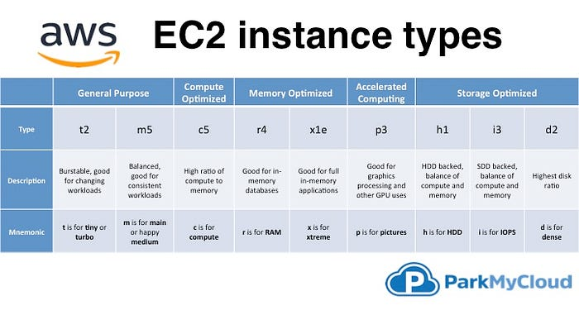
Where t is for tiny or turbo.
m is for main choice or happy medium.
c is for compute
r is for RAM.
x is for Xtreme, as in “Xtreme RAM”
p is for pictures (graphics).
h is for HDD.
i is for IOPS.
d is for dense.
- General-Purpose Instances: These instances are good for a wide range of applications and offer a balance of computing power, memory, and networking resources.
- Compute-Optimized Instances: These instances are designed for tasks that require a lot of processing power, such as scientific modelling or gaming servers.
- Memory-Optimized Instances: These instances are ideal for tasks that require a lot of memory, like in-memory caching or high-performance databases.
- Storage-Optimized Instances: These instances are optimized for workloads that need a large amount of storage, like big data processing or data ware housing.
- Accelerated Computing Instances: These accelerated computing instances come equipped with various types of hardware accelerators like graphics processing units (GPUs), application-specific integrated circuits (ASICs), or field-programmable gate arrays (FPGAs), which are housed in cloud data.
Parameters | AWS | Azure
Launched Date | Launched in 2006. | Launched In 2010.
Market Share | 31% Share of the global computing market | 11% Share from the worldwide market.
Availability Zone | 61 Availability Zone | 140 Availability Zones
Storage services | - S3  - Buckets  - EBS  - SDB  - domains  - Easy to use  - SQS  - CloudFront  - AWS Import/Export | - Blob Storage  - Containers  - Azure Drive  - Table Storage  - Tables  - Storage Stats
Databases Services | - MySQL  - Oracle  - DynamoDB | - MS SQL  - SQL Sync
Deployment Services | - Amazon Web Services  - Amazon Machine Instance (AMI)  - Traditional Deployment Models  - Fine-grained updates  - Elastic Beanstalk  - Cloud Formation | Cspkg (fancy zip file)  Upload via portal or API via blob storage  Course-grained updates  “click to scale.”  More magic
Networking Services | - IP/Elastic IP/ELB  - Virtual Private Cloud  - Route 53  - ELB  - Firewall heavily configurable | - Automatic IP assignment  - Load-balancing  - Azure Connect  - Balancing  - Endpoints defined in csdef/cscfg
Price | Per hour- rounded up | On-demand reserved spot.
Customers | Adobe, Airbnb, Expedia, Yelp, Nokia, Netflix, Novartis. | Pearson, 3M, Towers Watson, NBC, Essar, Serko, etc.
Type of Cloud | Virtual Private Cloud (VPC) | Virtual Network
Connection type | Direct Connect | ExpressRoute
Pricing models | - Free Tier  - Per Hour  - Free Trial Per Minute  - No change for stopped  - Pay for EBS volume | - Free Trial  - Per Minute
Government Cloud | AWS has an edge as far as government cloud offerings. | Limited reach for government cloud offerings.
Support for Hybrid cloud | Does not offers the best of hybrid cloud support. | With Hybrid Cloud, organizations can integrate onsite servers with Cloud instances.
Ecosystem | AWS has a software marketplace with an extensive partner ecosystem. | With very few Linux options, Azure doesn’t’ have a big ecosystem.
Support for Big Data | EBS storage is ideal for handling big data. | Standard storage has many issues for big data, and therefore you need premium storage.
Maturity | More mature cloud environment for big data. | The less mature environment for big data.
Machine access | In AWS machine can be accessed separately. | Machines are grouped into cloud service and respond to the same domain name with various ports.
Salary | The average salary for “AWD engineer” is approximately $141,757 per year for Software Architect. | The average salary for “Microsoft Azure” ranges from approximately $113,582 per year.
Key features | Zero setups, Detail Monitoring, Auto-scaling groups. | Startup friendly, High performance, Low cost.
Long term data archiving | Allows long term data archiving and retrieval. | Does not offer any long term data archiving and retrieval option.
Security | Security is provided using defined roles with permission control feature. | Provides security by offering permissions on the whole account.
In the past year, Azure’s cloud adoption rate is almost 85 percent that of AWS’, up from 70 percent last year.
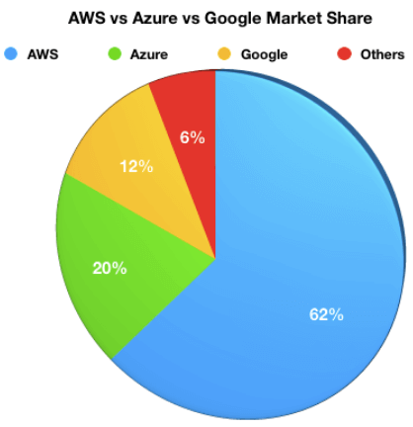
AWS and Azure comparison of Market share

Advantages of AWS
Here, are significant advantages of adopting AWS cloud services:
- Compute Cloud allows you to increase or decrease storage according to the need of your organization
- AWS enables you to select an operating system, programming language, database of your choice.
- Broad & deep service offerings
- Robust partner ecosystem
- Trusted by high-profile customers
- High Transfer Stability
- Minimal information is lost during server and storage transfer
- Offers more data centres for availability and low latency
- Better DevOps support
- Simpler licensing method
- Stronger support for Bl and analytics

Advantages of Azure
Here, are some major advantages of using Azure cloud services:
- Capability for developers and users to create, maintain and deploy applications
- Fully scalable cloud computing platform offers open access across multiple languages, frameworks, and tools
- Total support for Microsoft legacy apps
- Greater awareness of enterprise needs
- Easy one-click migrations in many cases
- Conversion of on-prem licenses to the cloud
- Support for mixed Linux/Windows environments
- Offers inbuilt tool like Azure stack to help the organization deliver Azure service from the own data center

Disadvantages of AWS
Here, are few drawbacks of Amazon Web Services:
- Less hybrid- cloud-friendly
- AWS elastic load balancer is not equipped to handle as many requests as it receives
- AWS lacks customer support, so it more suitable for a technically savvy group of consumers and those companies who have their inbuild tech support team
- The number of choices offered by AWS is confusing to those who may not speak the language of technology.
- Incompatible and Weak Hybrid Strategy
- AWS is a less open private cloud. This makes it an unpopular storage option for sensitive industries like banking
- AWS has too many products which makes the selection process much harder

Disadvantages of Azure
The major Drawbacks of Azure cloud services are:
- Customer service is not transparent, and data is hosted globally. So, if you have data restrictions where it must be stored in a specific country, at that time you need to verify/specify with Microsoft
- You will be charged extra for paying as you go
- Azure cloud-based services are full of glitches. To fix these bugs, you will need to spend additional money
- Less flexibility about non-Windows server platforms, when compared to AWS.
-------------------------------------------------------------------------------------------------
EC2 Launch Instance Types
1.On demand Instance.
2.Reserved Instance.
3.Spot Instance.
4.Dedicated Host.
5.Dedicated Instance.
-------------------------------------------------------------------------------------------------

On-demand instances
- On-demand is the most used launch type to launch the EC2 instances. While launching the EC2 instance using the on-demand launch type, you only need to request the EC2 instance, and it is immediately available for you. You can terminate the instance at any time without any extra charges.

Use cases
AWS recommends using the on-demand instances for the following use cases.
- Short term applications
- Testing purposes
- Irregular workloads
- Un-interrupted workloads

Reserved instances
- As compared to on-demand instances, reserved instances can be used to reserve the instance for a specific time period. The reservation time for the reserved instances is between 1 and 3 years. You make a commitment with AWS that you will use a specific compute capacity for 1 or 3 years, and AWS offers up to 72% discount as compared to on-demand instances.

Use cases
- Networking type, availability zone, and instance size can be changed
- Instance family, operating system, tenancy, and payment options can also be changed

Spot instances
- Spot instances are the spare EC2 capacity available on AWS EC2, which can be used at a very low price as compared to on-demand instances. Pricing of the spot instances is not fixed and varies depending upon the spare EC2 capacity available on AWS. But you can get a discount of up to 92% on on-demand instances while using the spot instances.

Use cases
- Spot instances are very cost-effective as compared to on-demand instances, but AWS manages the lifecycle of this instance. Following are some use cases of the spot instances.
- Data analysis
- Batch jobs
- Background processing
- Optional tasks

Dedicated instances
- When you launch an on-demand, reserved, or spot instance, AWS creates your VM on the hardware that is shared with other customers’ VMs. To launch your EC2 instance on the hardware that is dedicated to a single customer, AWS provides a Dedicated instance launch type.
- AWS dedicated instances may share hardware with other EC2 instances that are not dedicated instances from the same account. Dedicated instances can only be launched in AWS VPC, and you need to specify the instance tenancy as Dedicated while launching the dedicated instance.

Dedicated hosts
- Amazon EC2 dedicated hosts allow you to run your VMs on the physical server that is fully dedicated to you. You can bring software licenses from different vendors like Microsoft, Amazon EC2, or Oracle, and you can get cost-effectiveness and flexibility to use your own license.
- Meet corporate compliance requirements
- Save money on license cost
------------------------------------------------------------------------------------------------------------

Simple Notification Service (SNS).

- SNS is a fully managed messaging service that enables you to send notifications from the cloud to various subscribers, including individuals, groups of people, or distributed systems.

--------------------------------------------------------------------------------------------------------

Virtual Private Cloud (VPC).
- It is a logically isolated virtual network within the AWS cloud where you can launch AWS resources such as Amazon EC2 instances, RDS databases, and more. VPC allows you to create a virtual network environment that closely resembles a traditional on-premises network, with control over IP addressing, subnets, routing, security, and network gateways.
- In this Vpc we have public and private subnets.

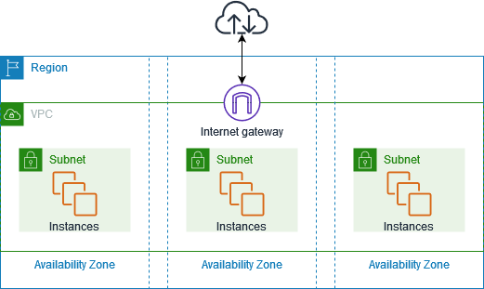

Virtual private clouds (VPC)
- A VPC is a virtual network that closely resembles a traditional network that you'd operate in your own data center. After you create a VPC, you can add subnets.
Subnets
- A subnet is a range of IP addresses in your VPC. A subnet must reside in a single Availability Zone. After you add subnets, you can deploy AWS resources in your VPC.
IP addressing
- You can assign IP addresses, both IPv4 and IPv6, to your VPCs and subnets. You can also bring your public IPv4 and IPv6 GUA addresses to AWS and allocate them to resources in your VPC, such as EC2 instances, NAT gateways, and Network Load Balancers.
Routing
- Use route tables to determine where network traffic from your subnet or gateway is directed.

CREATING THE EC2 INSTANCE:

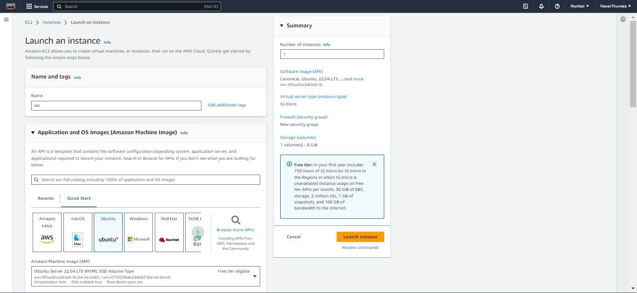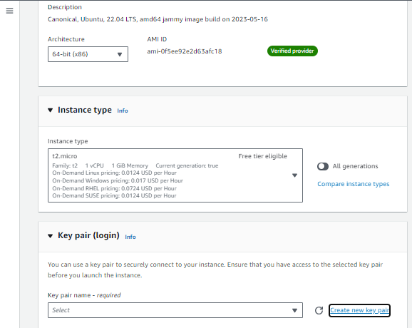at creating a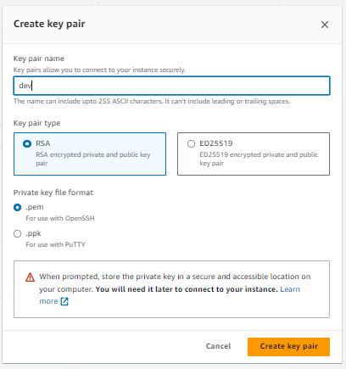
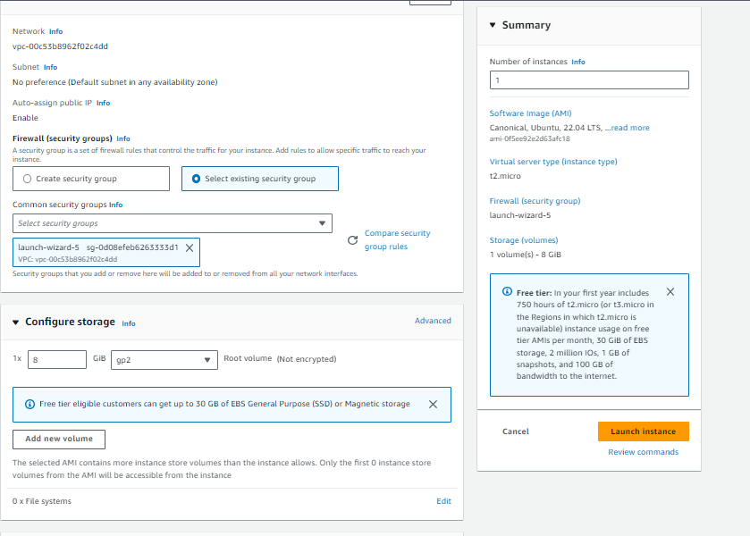

- After giving parameters to the EC2 we can launch the instance.

CLOUD WATCH

- CloudWatch enables you to monitor your complete stack (applications, infrastructure, network, and services) and use alarms, logs, and events data to take automated actions and reduce mean time to resolution (MTTR)

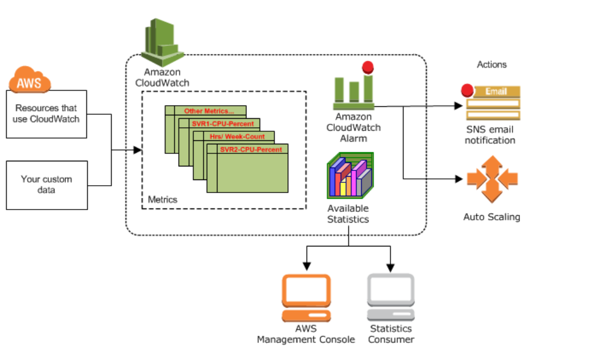

- The two types of CloudWatch alarms are Metric Alarm and Composite Alarms.
- The three are OK, Alarm, and insufficient Data. A Metric Alarm watches a single
- Metric or the result of an expression or calculation.
- Benefits of Cloud watch:
- AWS Clouds Watch provides real-time insights so that you can optimize operational costs and AWS applications and resources.

- AWS CloudWatch provides automatically collect data from AWS services such as Amazon EC2 instances, Amazon EBS volumes, and Amazon RDS database (DB) instances
- How to create an ALARM an EC2 instance:

- First, we open the AWS services:
- After opening the service of CLOUD WATCH service
- Create an alarm:
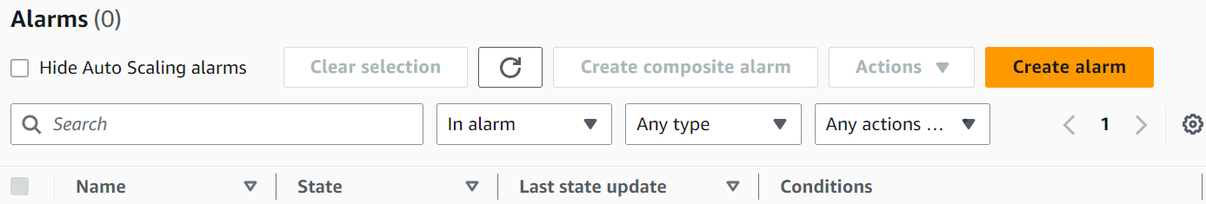
Select to create an alarm after that Metric we become:

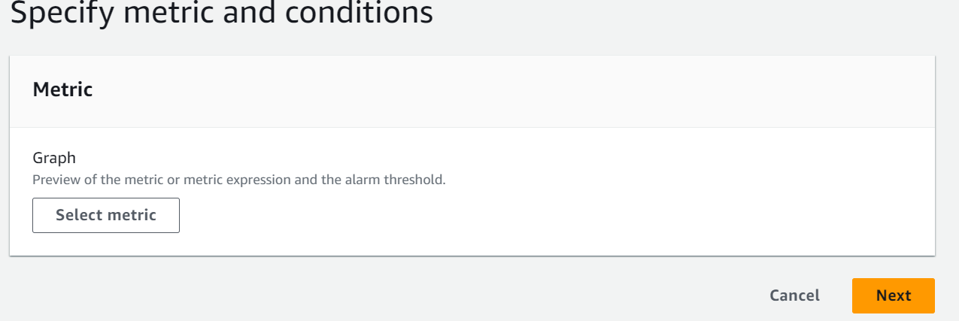

After selecting the Metrics and will be the browse of EC2 instance:

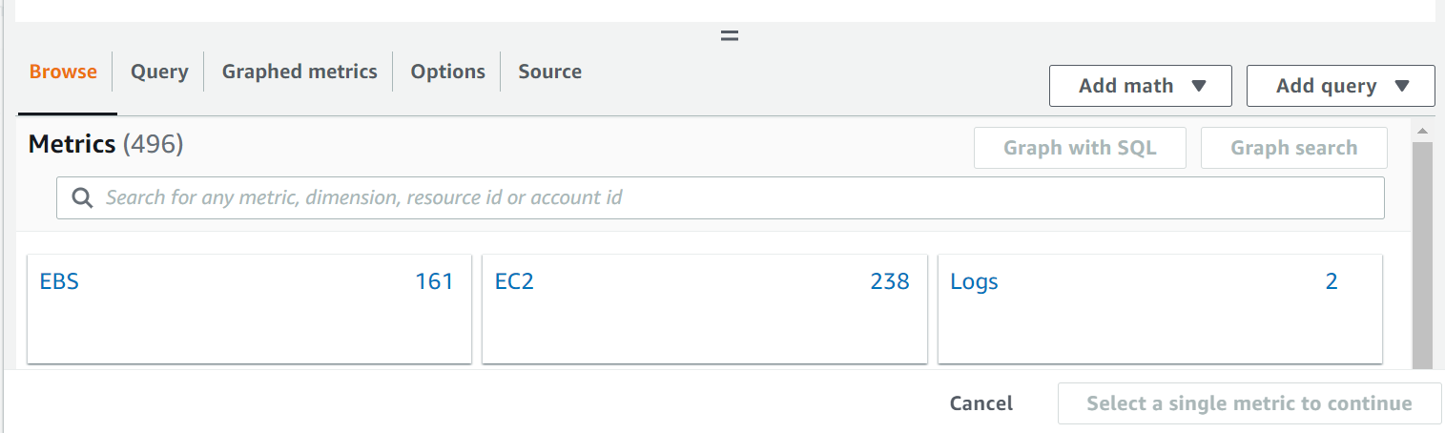
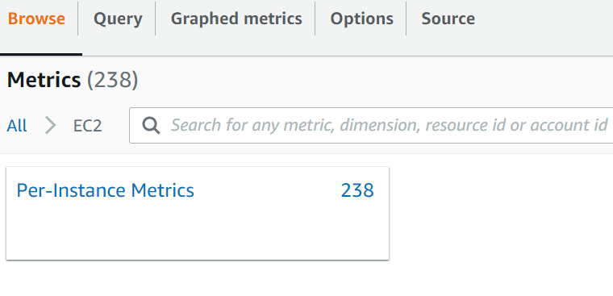

- After selecting the Pre-instance matrices. And go to the EC2 instance and select the instance that is running. After that instance will open see the monitor view. And select the CPU utilization Select.

- After selecting the alarm, it shows that
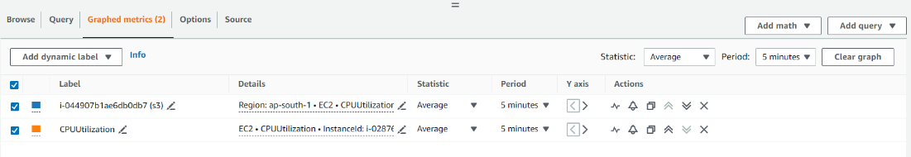
Then select alarm

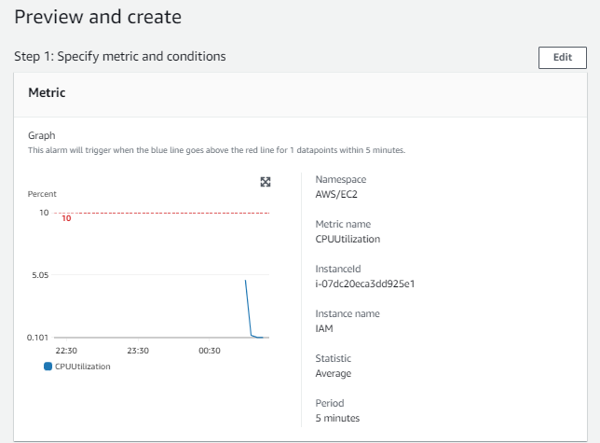
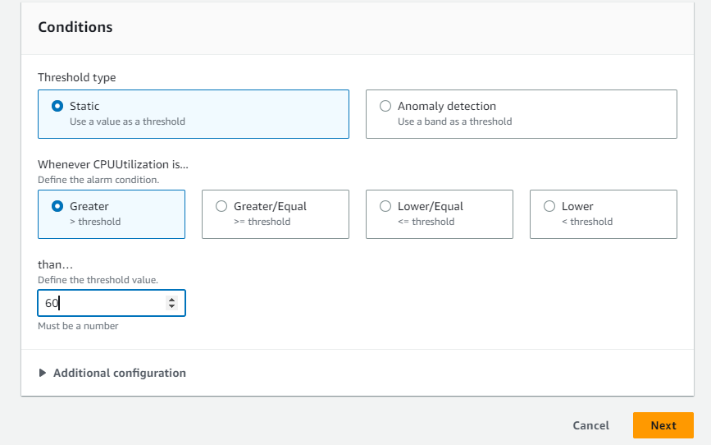
Click on the next button

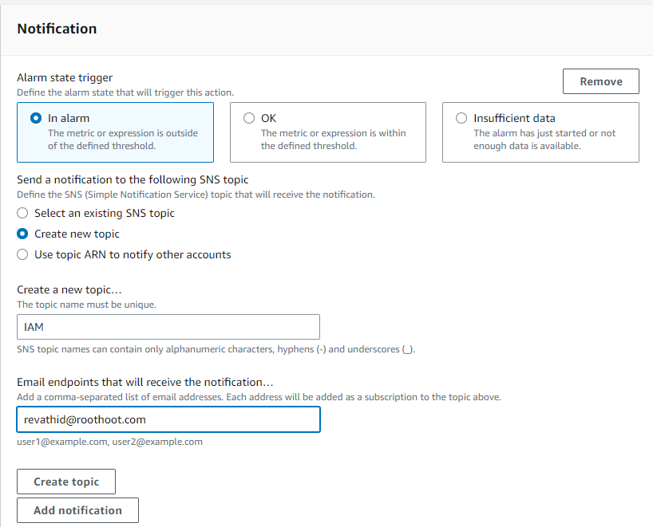
After creating the topic, the email notification will be come
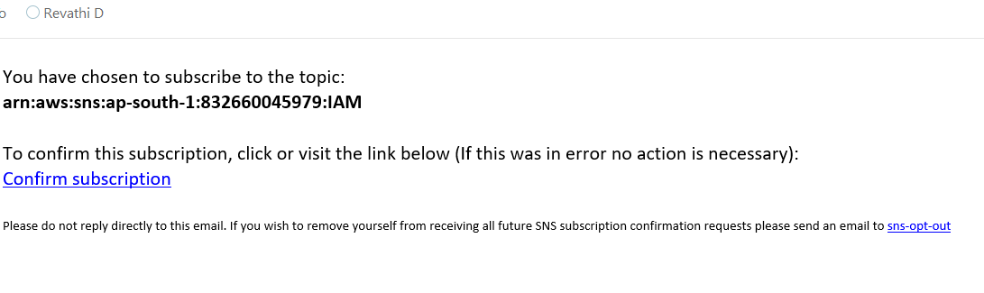
Subscription conforms
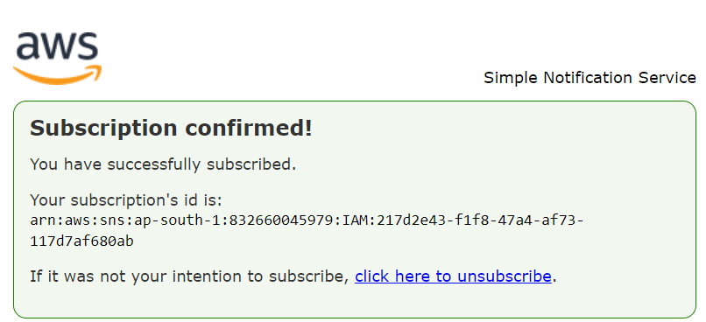
After that we select the EC2 action
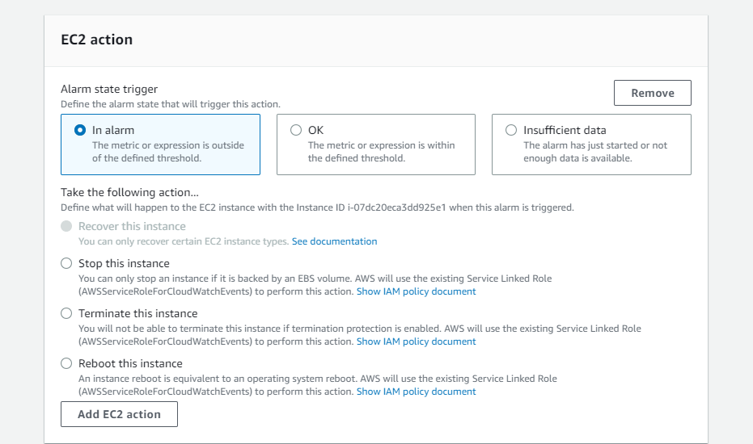

And click the option what action we want after that click the next button

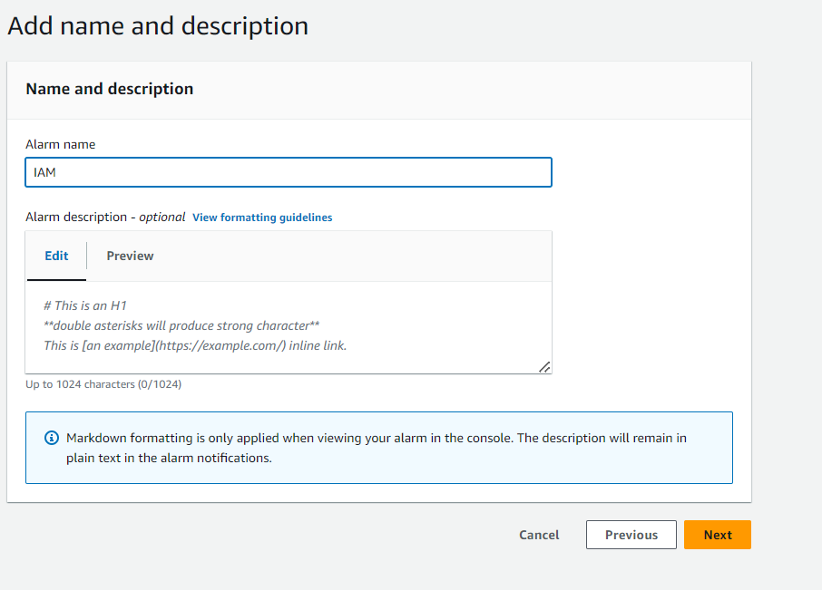

- Give the name of the alarm.
- After that create an alarm. Open the select the instance and connect to the server
- After applying for the commands. Use the stress command.
- The stress commands is
- Sudo apt-get update
- Sudo apt-get install stress
- Stress –cpu 1
- Or
- Stress –cpu 10 5m
- It will increase up to 10 % in 5 minutes.
- After that the CPU crosses the utilization. The email notification Trigger.

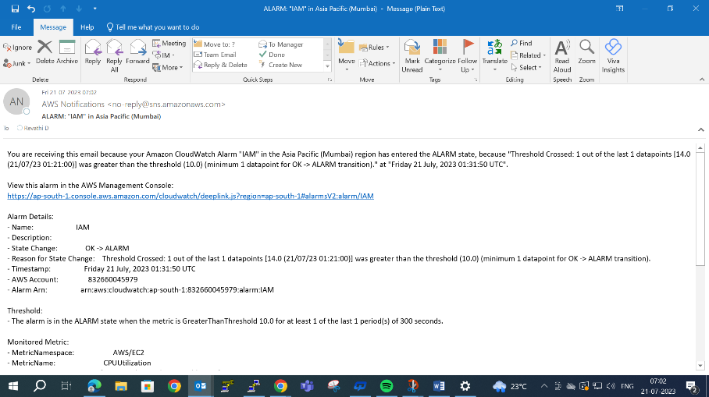
After the instance will show in alarm

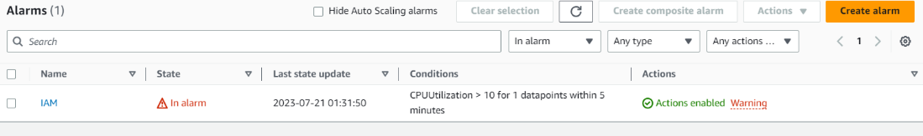

- The important note after completing the task. alarm action will be deleted. Otherwise the bill will be generating. So, delete the instance.

- TASK: Creating a alarm for billing account:

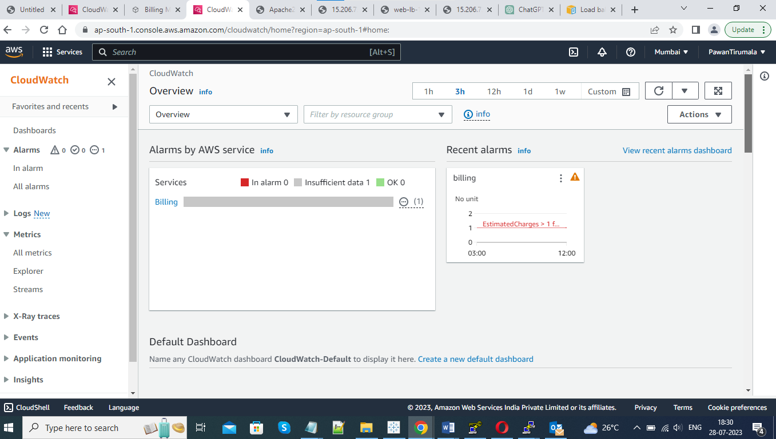

AMI (Amazon Machine Images).

- An AMI is a virtual image used to create a virtual machine within an EC2 instance.
- You can also create multiple instances using single AMI when you need instances with the same configuration.
- It also provides a template for the root volume of an instance.
- You can use an AMI to launch EC2 instances.
- You can also copy an AMI to some different region.
- When AMI is no longer required, then you can also deregister it.

How to create an AMI in EC2 instance:

- To open the EC2 service and instance will open after select the instance.

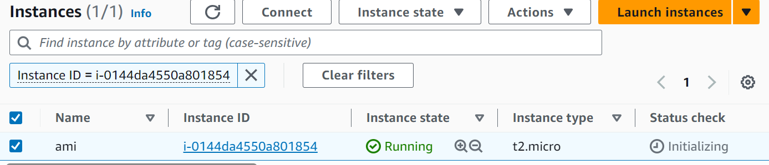

- Select the action to select the images and templates after select the creating image

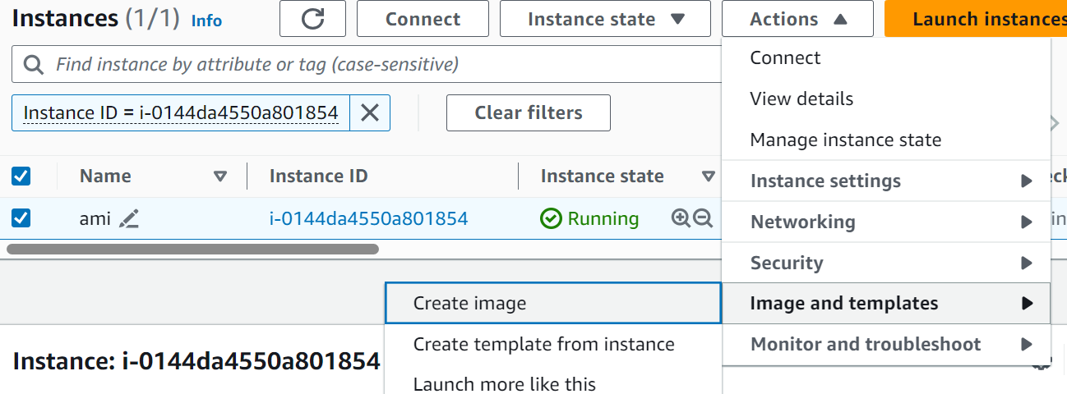

- After that create the ami
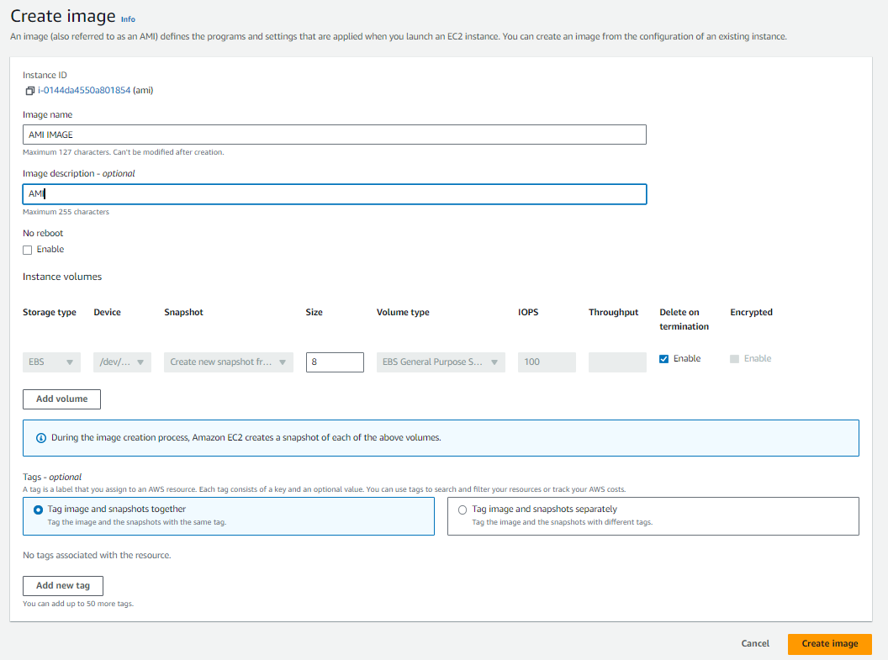
- The AMI will be created

- Using this AMI to launch the instance

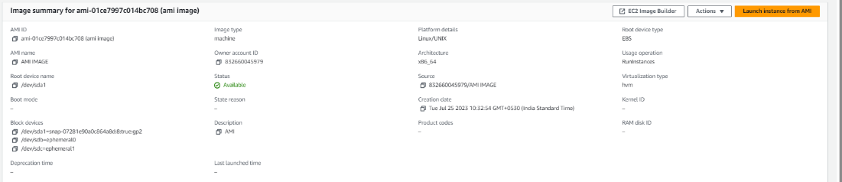

- Launch the instance:

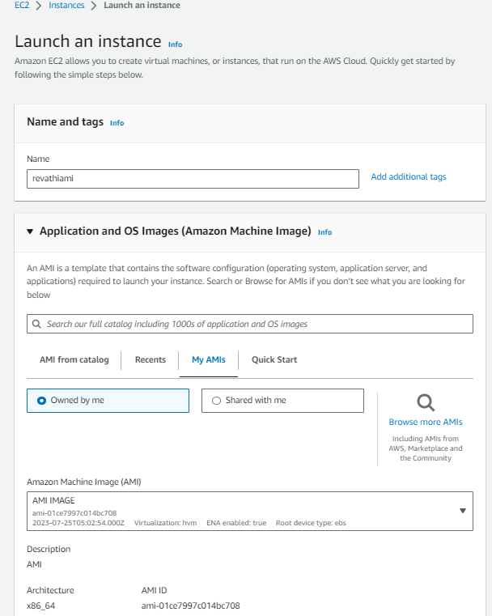
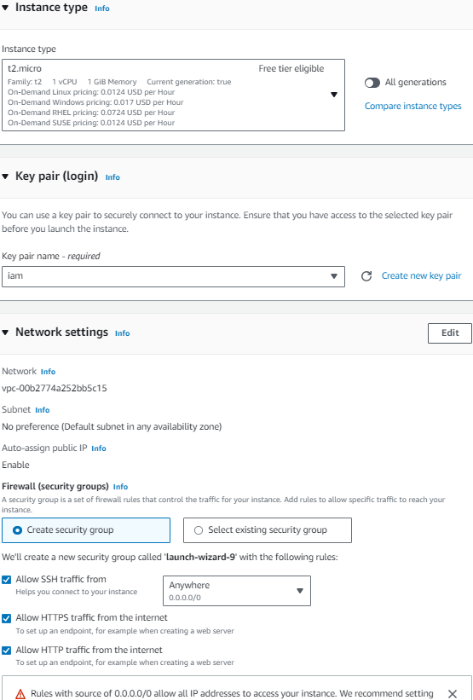

- After using the AMI to connect the instance
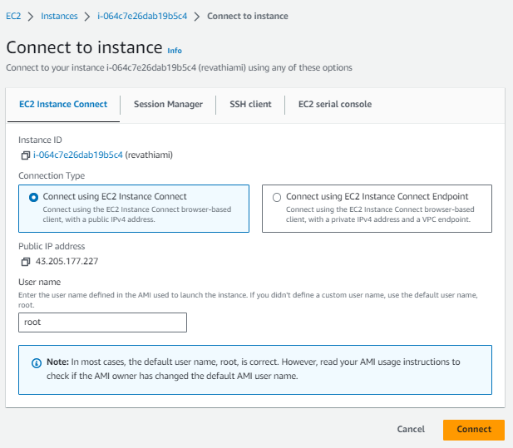

- At last we created the our own AMI to Ec2 instance.

How to create a web server& web page for EC2 instances and how to connect with load balancer using ec2 instances?

- First, we create the ec2 instance in the operating system in quick start.
- The second step is to create ec2 instance in OWN AMI, s.

Creating a web page:

- The commands
- Sudo apt-get update
- Sudo apt-get upgrade
- Sudo apt install apache2
- Sudo systemctl start apache2
- Sudo systemctl status apache2
- 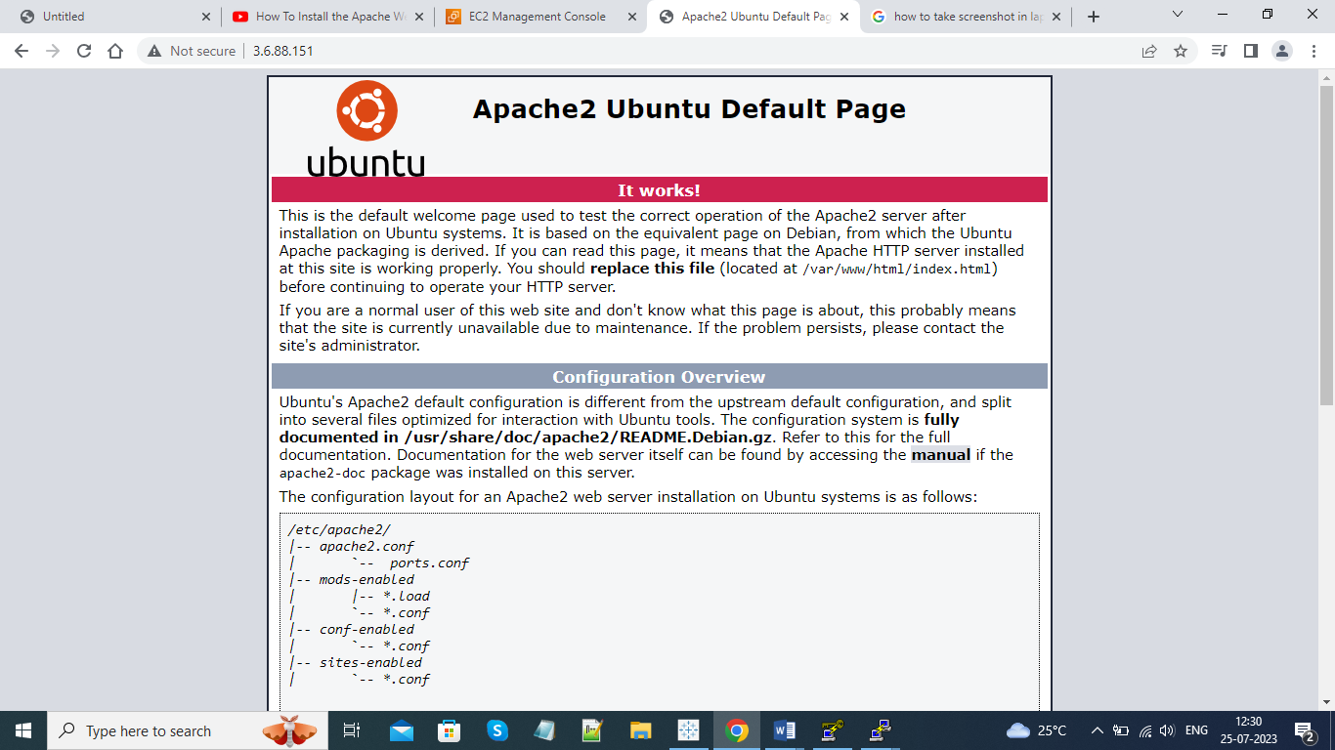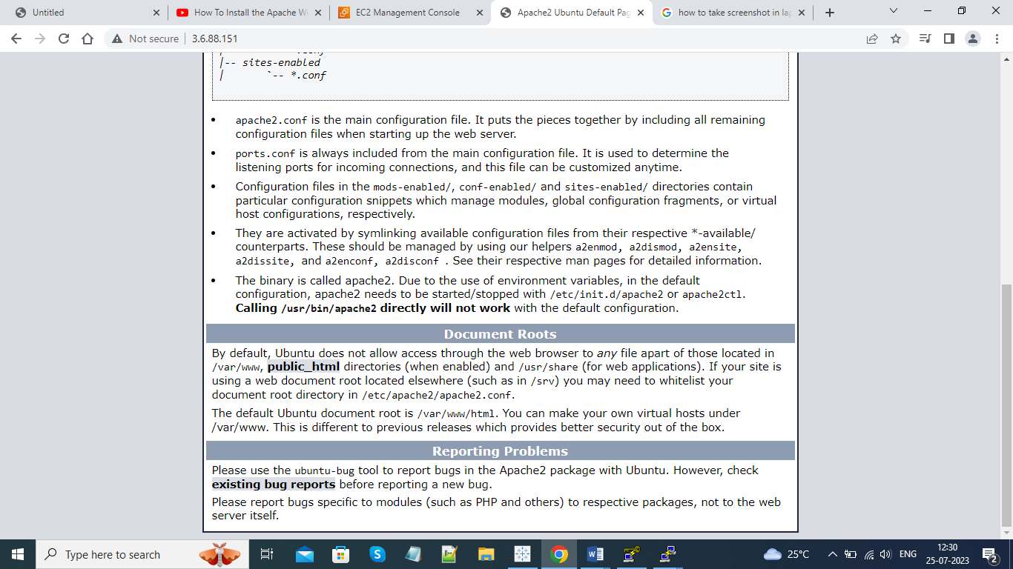
- After create a web page

- To create in html page
- Example:
- Dev.html, abc.html....
- After creating the file in html, we can edit text and it display on like below picture.

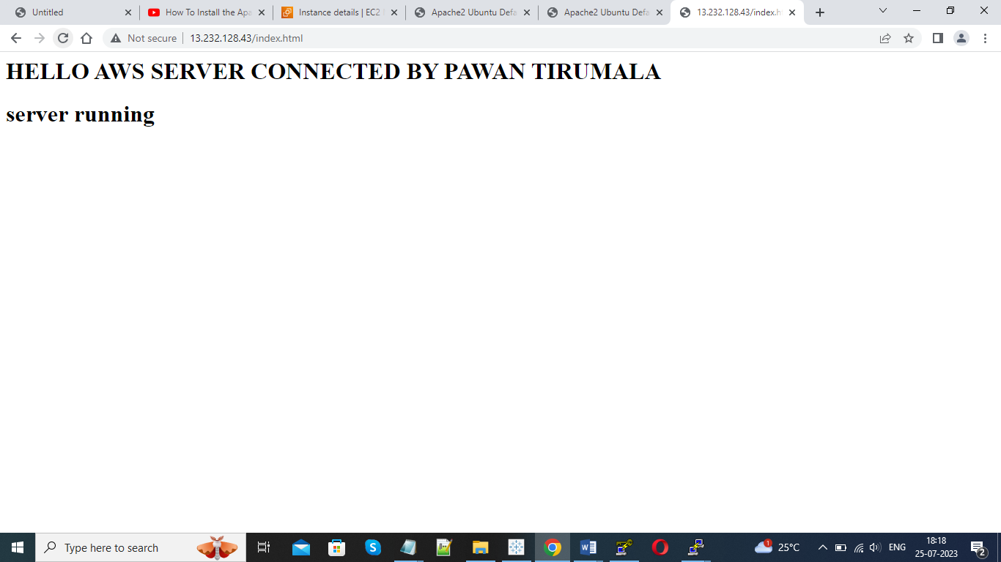

- After getting we can restart the apache2 by below commands.
- Sudo service apache2 restart
- Echo $?
- Sudo nano dev.html
- After completing the creation of 2 instances

How to connect the load balancer in ec2 instance and target groups?

First create load balancer

- Load balancer: Load balancer is a service that helps distribute incoming network traffic across multiple servers or instances to ensure high availability, fault tolerance, and optimal performance for applications. Load balancers play a crucial role in maintaining the scalability and reliability of applications in the AWS cloud.

Step by steps
- 1.
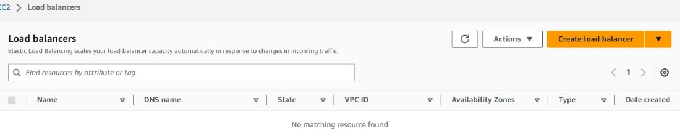

- Select the load balancer 2.

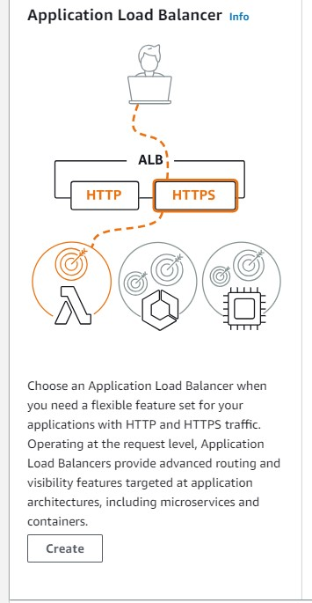

- Write the load balancer name and basic configuration

- 3.
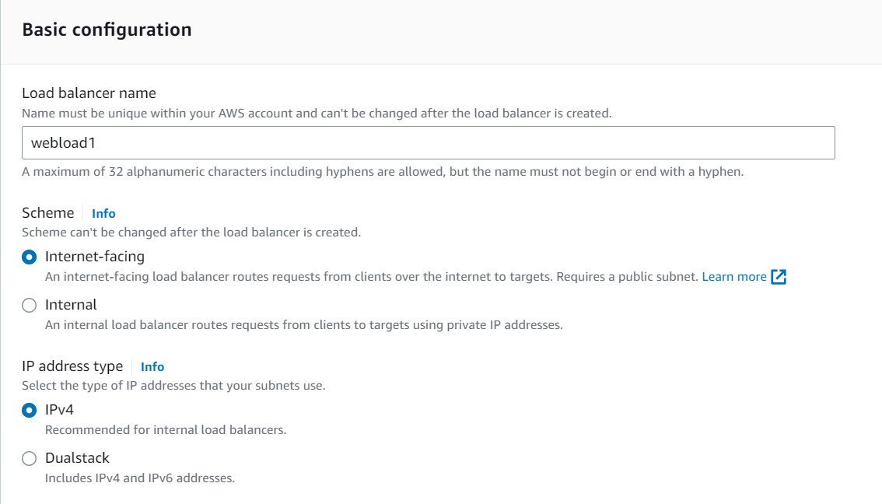
- 4.

- 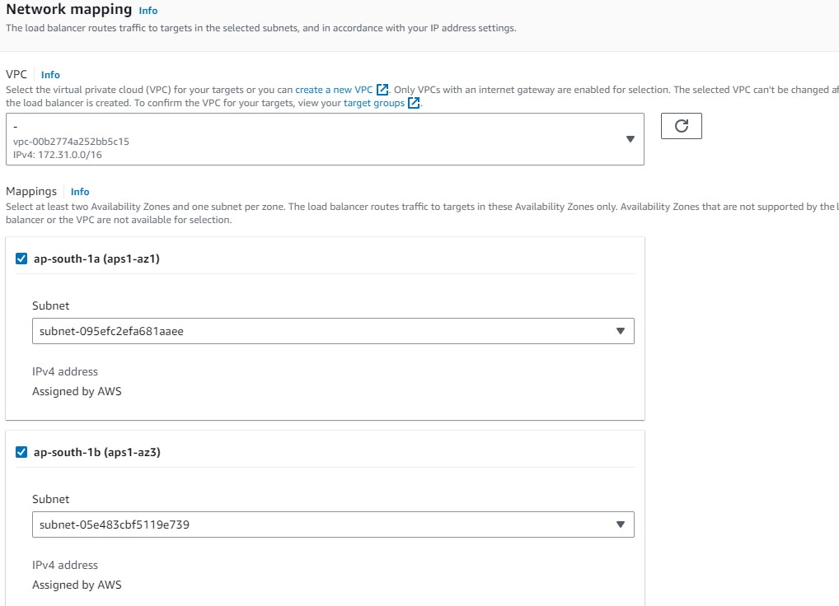
- 5.
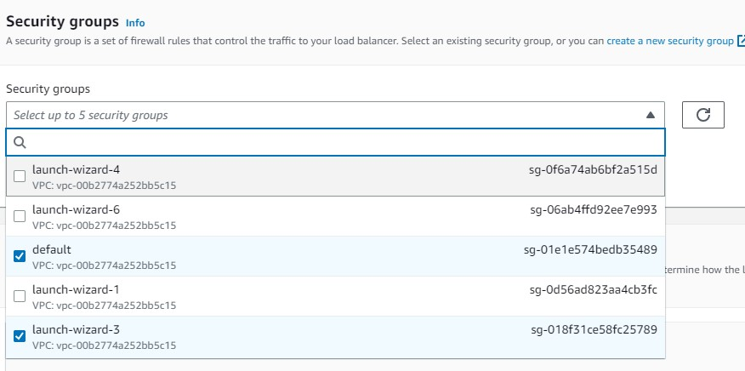
- 6.
- After we create a target group.
- Otherwise using the exiting target group.

- Create target step 1.

- 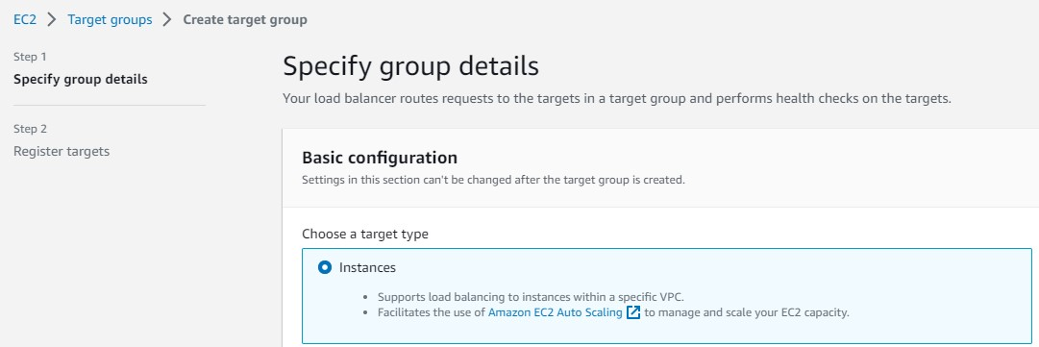

- 2.

- 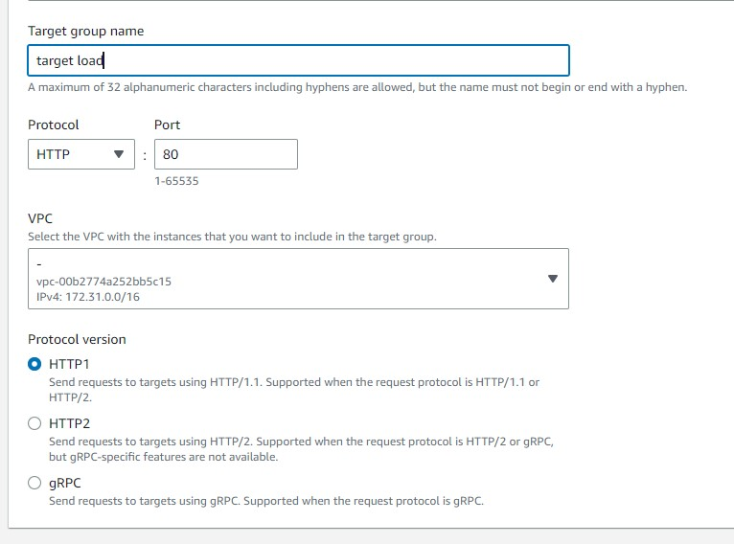

3.
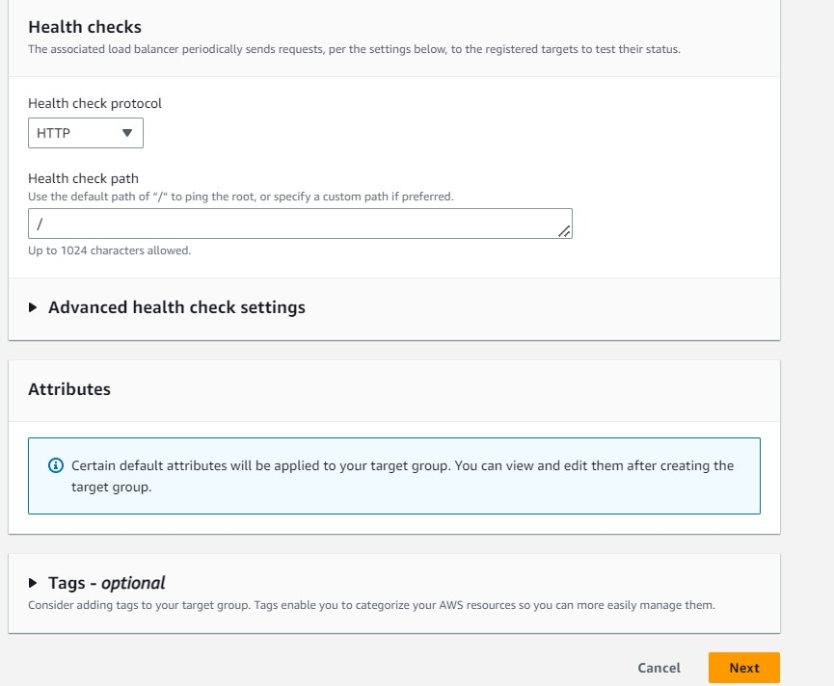

- Add the load balancer group
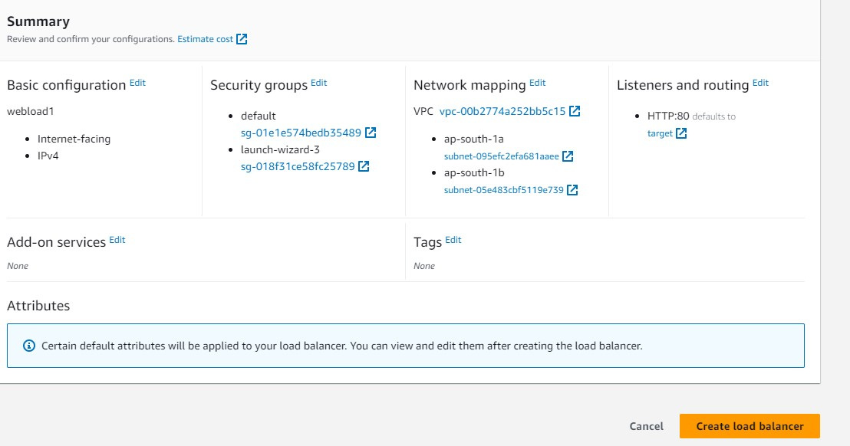

- Completely create the load balancer

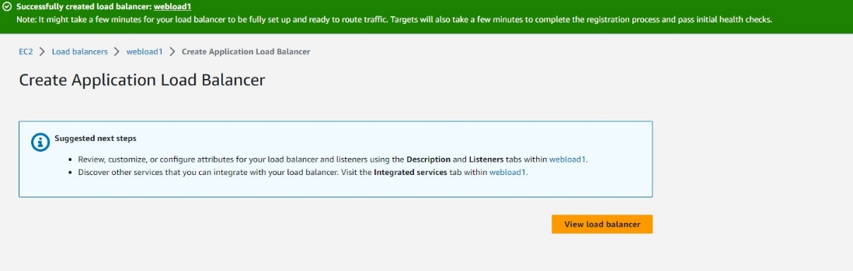

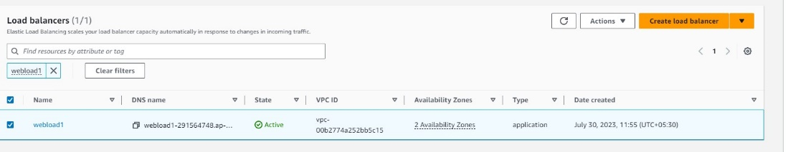

- Successfully create the load balancer and target group

Storage Section

In storage level we have object level storage & block level storage.

  - Amazon S3 (Simple Storage Service):
Amazon S3 is an object storage service that allows you to store and retrieve any amount of data at any time. It is ideal for storing and distributing large objects like images, videos, backups, logs, and other unstructured data. Some key concepts in Amazon S3 are:
• Buckets: A bucket is a container for storing objects. All objects are stored in a bucket, and each bucket has a unique name within AWS.
• Objects: Objects are the fundamental entities stored in S3. An object consists of the data itself, metadata (key-value pairs), and a unique identifier (key).
• Keys: Keys are unique identifiers for objects within a bucket. Each object in a bucket has a unique key.
• Regions: AWS S3 allows you to choose the geographic region where your data will be stored. The choice of region can impact latency and compliance requirements.
• Access Control Lists (ACLs) and Bucket Policies: These are used to manage access permissions to S3 buckets and objects.

Creating an S3 bucket:

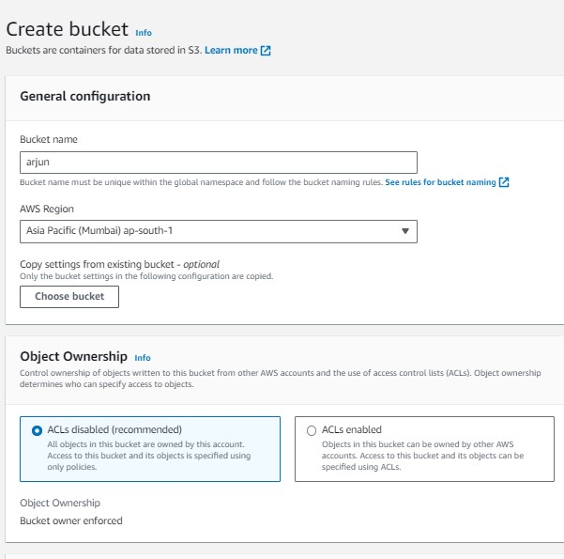
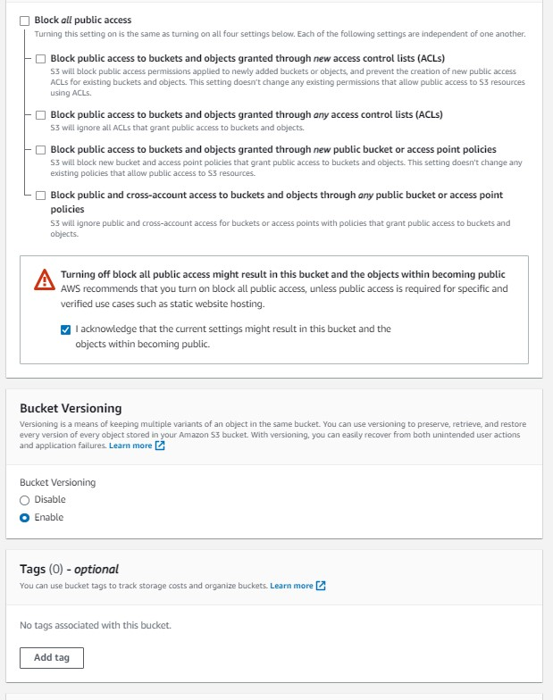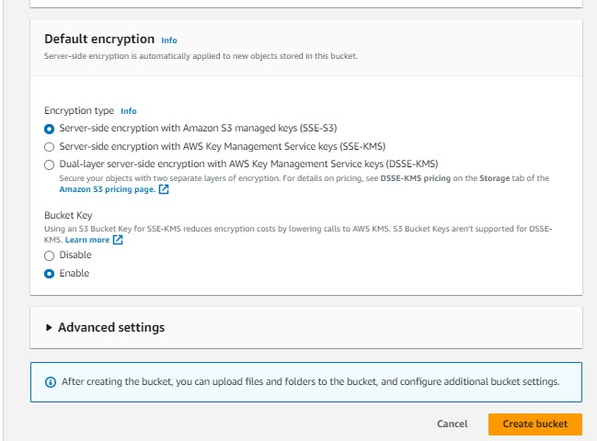

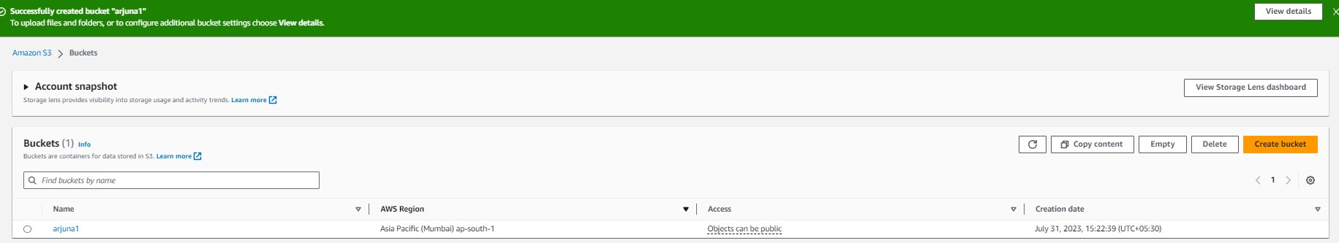

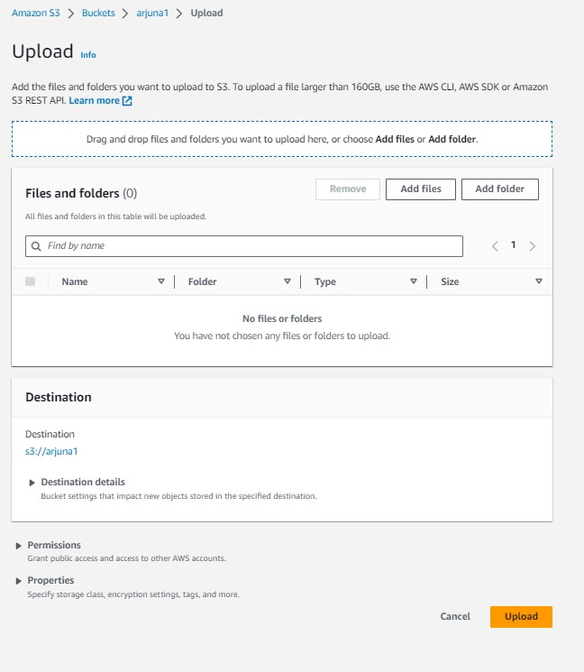

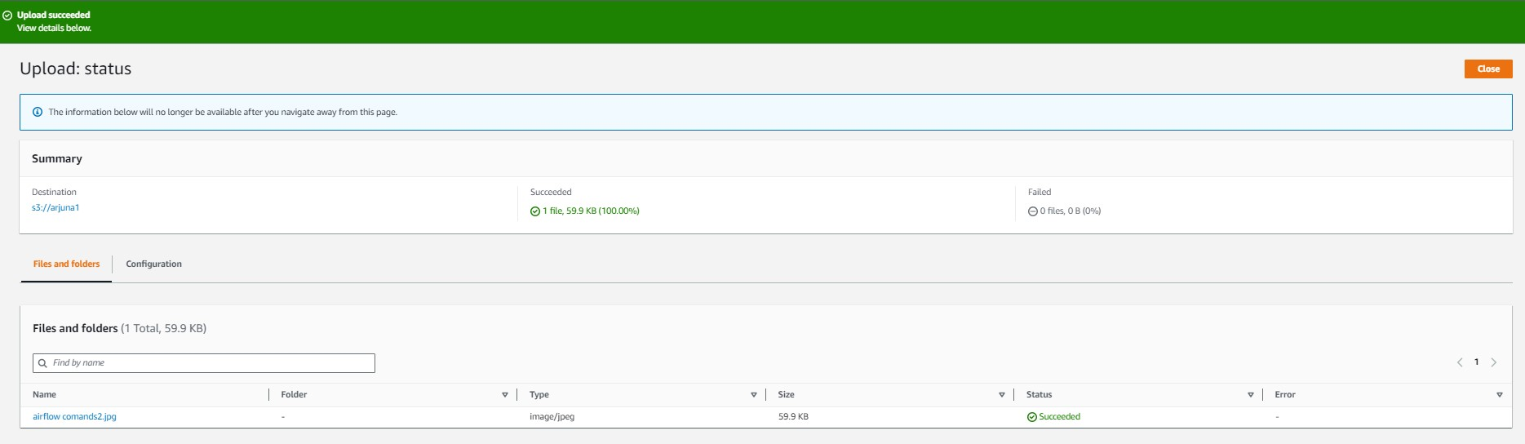

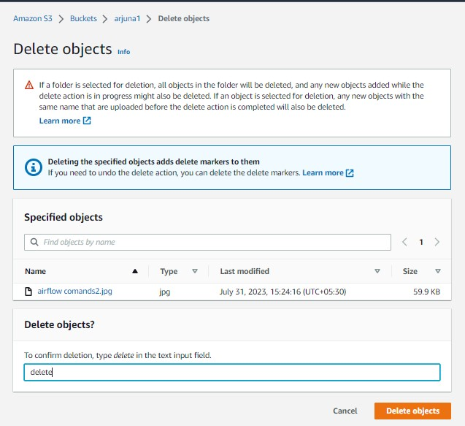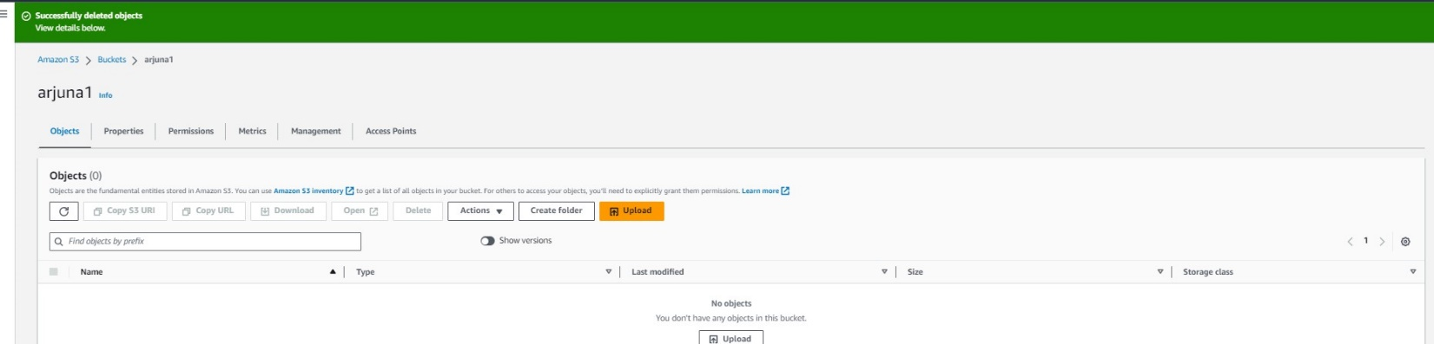

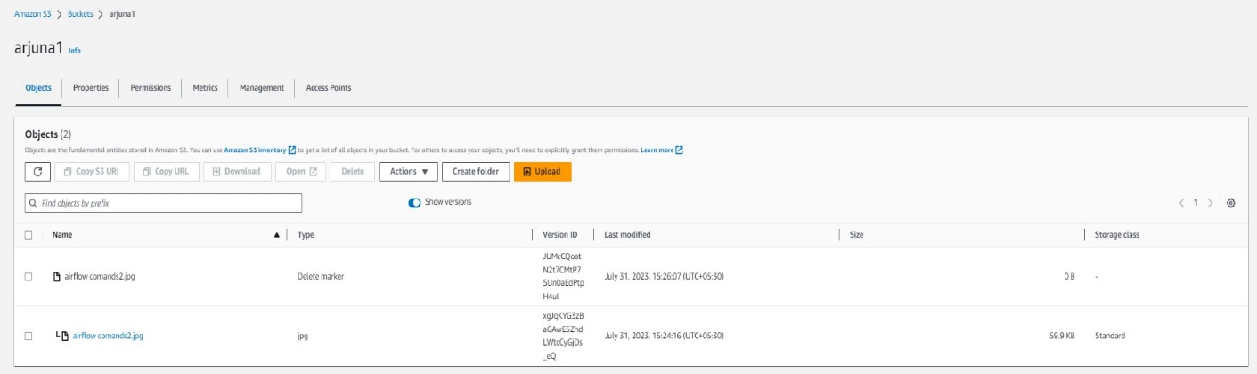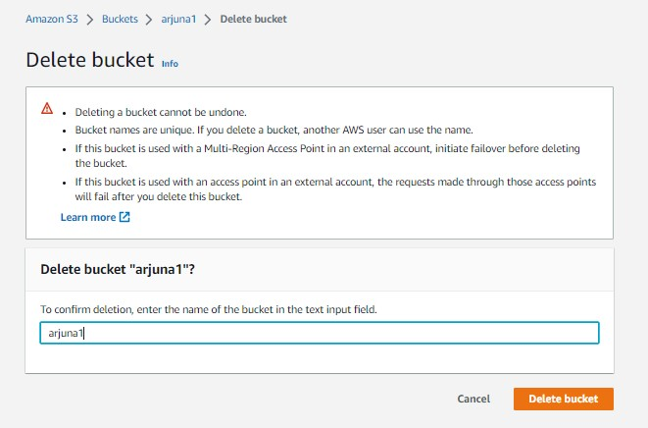

2. Amazon EBS (Elastic Block Store):
Amazon EBS provides persistent block-level storage volumes that can be attached to Amazon EC2 instances. EBS volumes function like hard drives and can be used for database storage, file systems, and more. Key concepts include:
• EBS Volume Types: AWS offers various EBS volume types optimized for different use cases, such as General Purpose SSD (gp2), Provisioned IOPS SSD (io1), Throughput Optimized HDD (st1), and Cold HDD (sc1).
• Snapshots: EBS snapshots are point-in-time backups of EBS volumes, which can be used to create new volumes or restore existing ones.

